SHIRE HIGHLANDS EDUCATION DIVISION MOCK EXAMINATIONS

2026 MALAWI SCHOOL CERTIFICATE OF EDUCATION MOCK EXAMINATION

AGRICULTURE
Paper II
Subject Number: M012/II
(40 Marks)

MARKING SCHEME

1. a Culling is the process of removing unproductive animals in the herd or flock
b Culling is important because
saves on feeding costs since only productive animals are kept
results in increased production as more attention is given to productive animals only
c i. two breeds
      - diary cattle
      - beef cattle
ii. Malawi Zebu is commonly kept in Malawi because it favours/adapt to high temperatures and little rainfall conditions in Malawi
iii Characteristics of Malawi Zebu
      - small body size
      - long calving intervals of up to 540 days
      - black, brown or white colour

2. A teacher brought the following materials to a following materials to a form four class.
- OMO solution
- Chopped maize stalks
- Water

a. State three steps that would be followed to treat the chopped maize stalks to be substrate suitable for mushroom production. (3 Marks)

Soak substrate into OMO solution.
Rinse the substrate with plenty water until the soap bubbles disappear.
Drain the water
(1 Mark for each step in that order)

b. Explain one importance of using chopped maize stalks as substrate suitable for mushroom production. (2 Marks)
Chopped maize stalks has large surface area (1) for mycelium growth/ running. (1)

c. (i). Balance sheet is a statement of all the assets and liabilities of a business at a specific
time usually taken on the last day of the financial year to show the net worth or net capital of the farm
(ii) -helps the farmer to campare prices for various markets and choose where to sell in
order to make profit
- Helps the farmer to compare prices for commodities at different times and choose when to sell to make profits
- Helps the farmer to calculate income for sales

Question 3

Provide the following
- Water
- 2 Tablespoon full of Loam soil in any container and label it ‘M’
- 5 Tablespoon full of Sandy soil in a clear container label it ‘N’.
- A stirring rod.
- One bean seed labelled X
- One maize seed labelled Y

3. You are provided with the following materials: Water, soil samples labelled M and N, a stirring rod and two crop seeds labelled X and Y.

Procedure
a. Plant the two crop seeds ‘X’ and ‘Y’ in container ‘M’.

(i) Identify the type of enterprise combination practiced.
Complementary enterprise (1 Mark)

(ii) Give one reason for the answer to 3a (i) (1 Mark)
Beans will fix nitrogen to be used for maize growth while maize will act as a stake for beans. (1)

b. State four steps that would be followed when determining texture of soil sample ‘N’ using sedimentation method. (4 Marks)

Fill the container with water.
Stir the contents with a stirring rod.
Leave the contents to settle.
Determine/ calculate the percentage of sand/ clay and silt using the volume occupied by each soil particle.
(1 Mark for each step in that order)

c. Conduct the experiment using steps in 3b.

(i) Draw the expected results. (2 Marks)

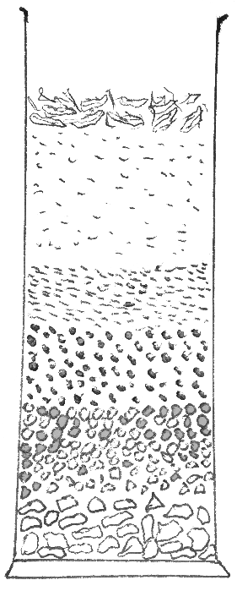
Expected results
Organic matter
Clay in suspension
Silt
Fine sand
Coarse sand
Gravel

(1 Mark for the diagram, 1 Mark for labelling)

(ii). Explain any one way in which the experiment is important in crop production.
The farmer will know the texture of the soil (1) that he can choose the right type of crop to grow/ frequency of irrigation/ system of irrigation. (1)
The farmer can determine the fertility of the soil (1) so that he can decide on amount of fertilizer to apply. (1)
The farmer can determine water holding capacity of soil (1) so that he/she can plan for drainage practices. (1)
(2 Marks for any one)

4. You are provided with three specimen labelled P, Q and R.

Provide the following:
- One Table spoon full of groundnut flour and label it P
- One Table spoon full of Urea and label it Q
- One stem of napier grass with at least two nodes and label it R

a. Which of the four specimens is a crop product. (1 Mark)
P/ groundnut flour (1 Mark)

b. State three crop processing activities that were done to obtain specimen ‘P’. (3 Marks)

Shelling
Drying
Pounding / milling

c. Identify the type of pasture labelled ‘R’.
Grass pasture (1 Mark)

d. Give one reason why specimen ‘Q’ is recommended to the type of pasture named in 4c. (2 Marks)
It contains nitrogen (1) hence recommended to grass pasture which does not fix nitrogen. (1)

e. Explain any one role of pasture ‘R’ in livestock production.
It is a source of feed nutrients/ vitamins which helps in heath of livestock.
It is a source of roughage (1) which help in digestion. (1)
(2 Marks for any one)

f. State one way of increasing shelf life of specimen P.
Drying
Adding salt / salting
(1 Mark for each)
END OF MARKING SCHEME
@ SHED 2026

